

Makara Model School
Charter, Strategic Plan and Annual Plans
2021 - 2023
Principals’ endorsement:
Board of Trustees’ endorsement:
Submission date to Ministry of Education:

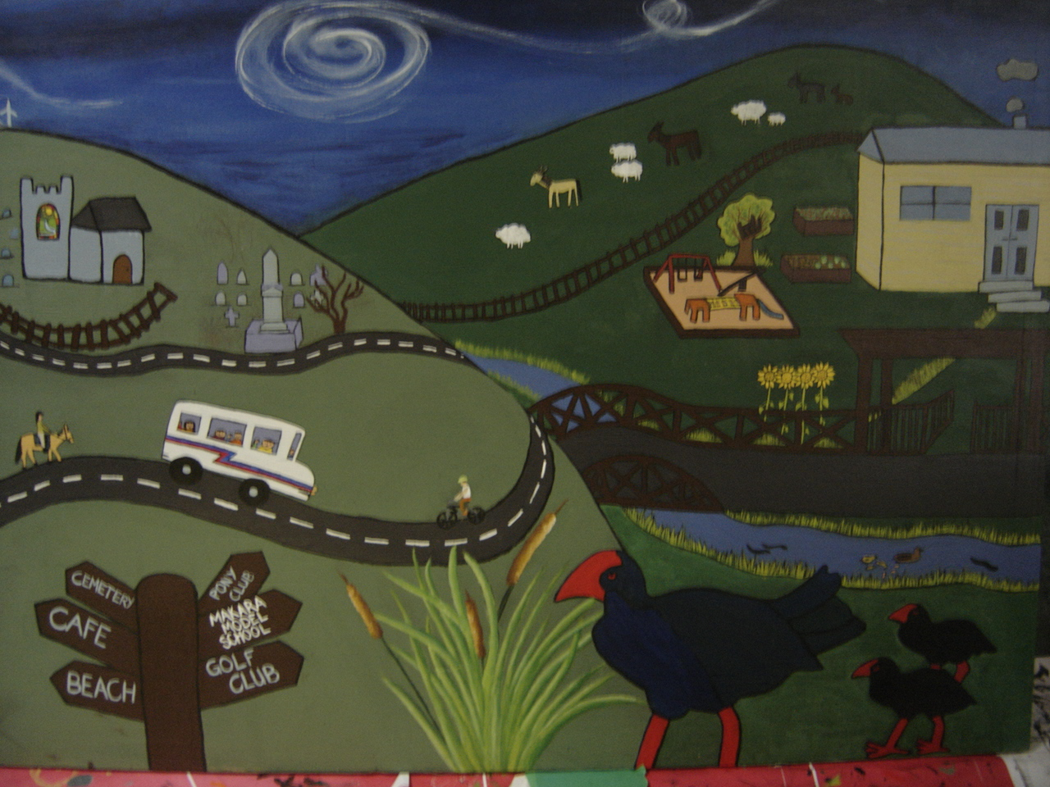
Our School Community Mural – Erected May 2012 Designed and painted by students and staff
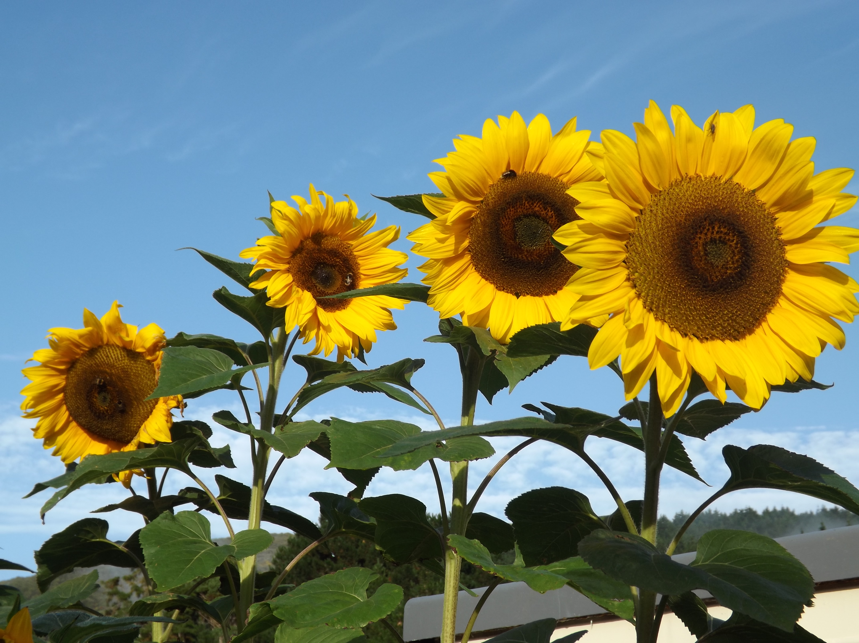
Te Ara o te Makara – The Makara Way

Mindful Aroha Kaitiakitanga Atawhai Respect Awhina

Mission Statement
Learning: For Life

School Vision
Makara Model School will be held in high regard in the community and surrounding areas as a
high quality, progressive, inclusive learning environment for children.

School Rules
Be respectful. Be responsible. Be kind.

Whakatauki
Whaia ti iti kahurangi – Reach For the Stars
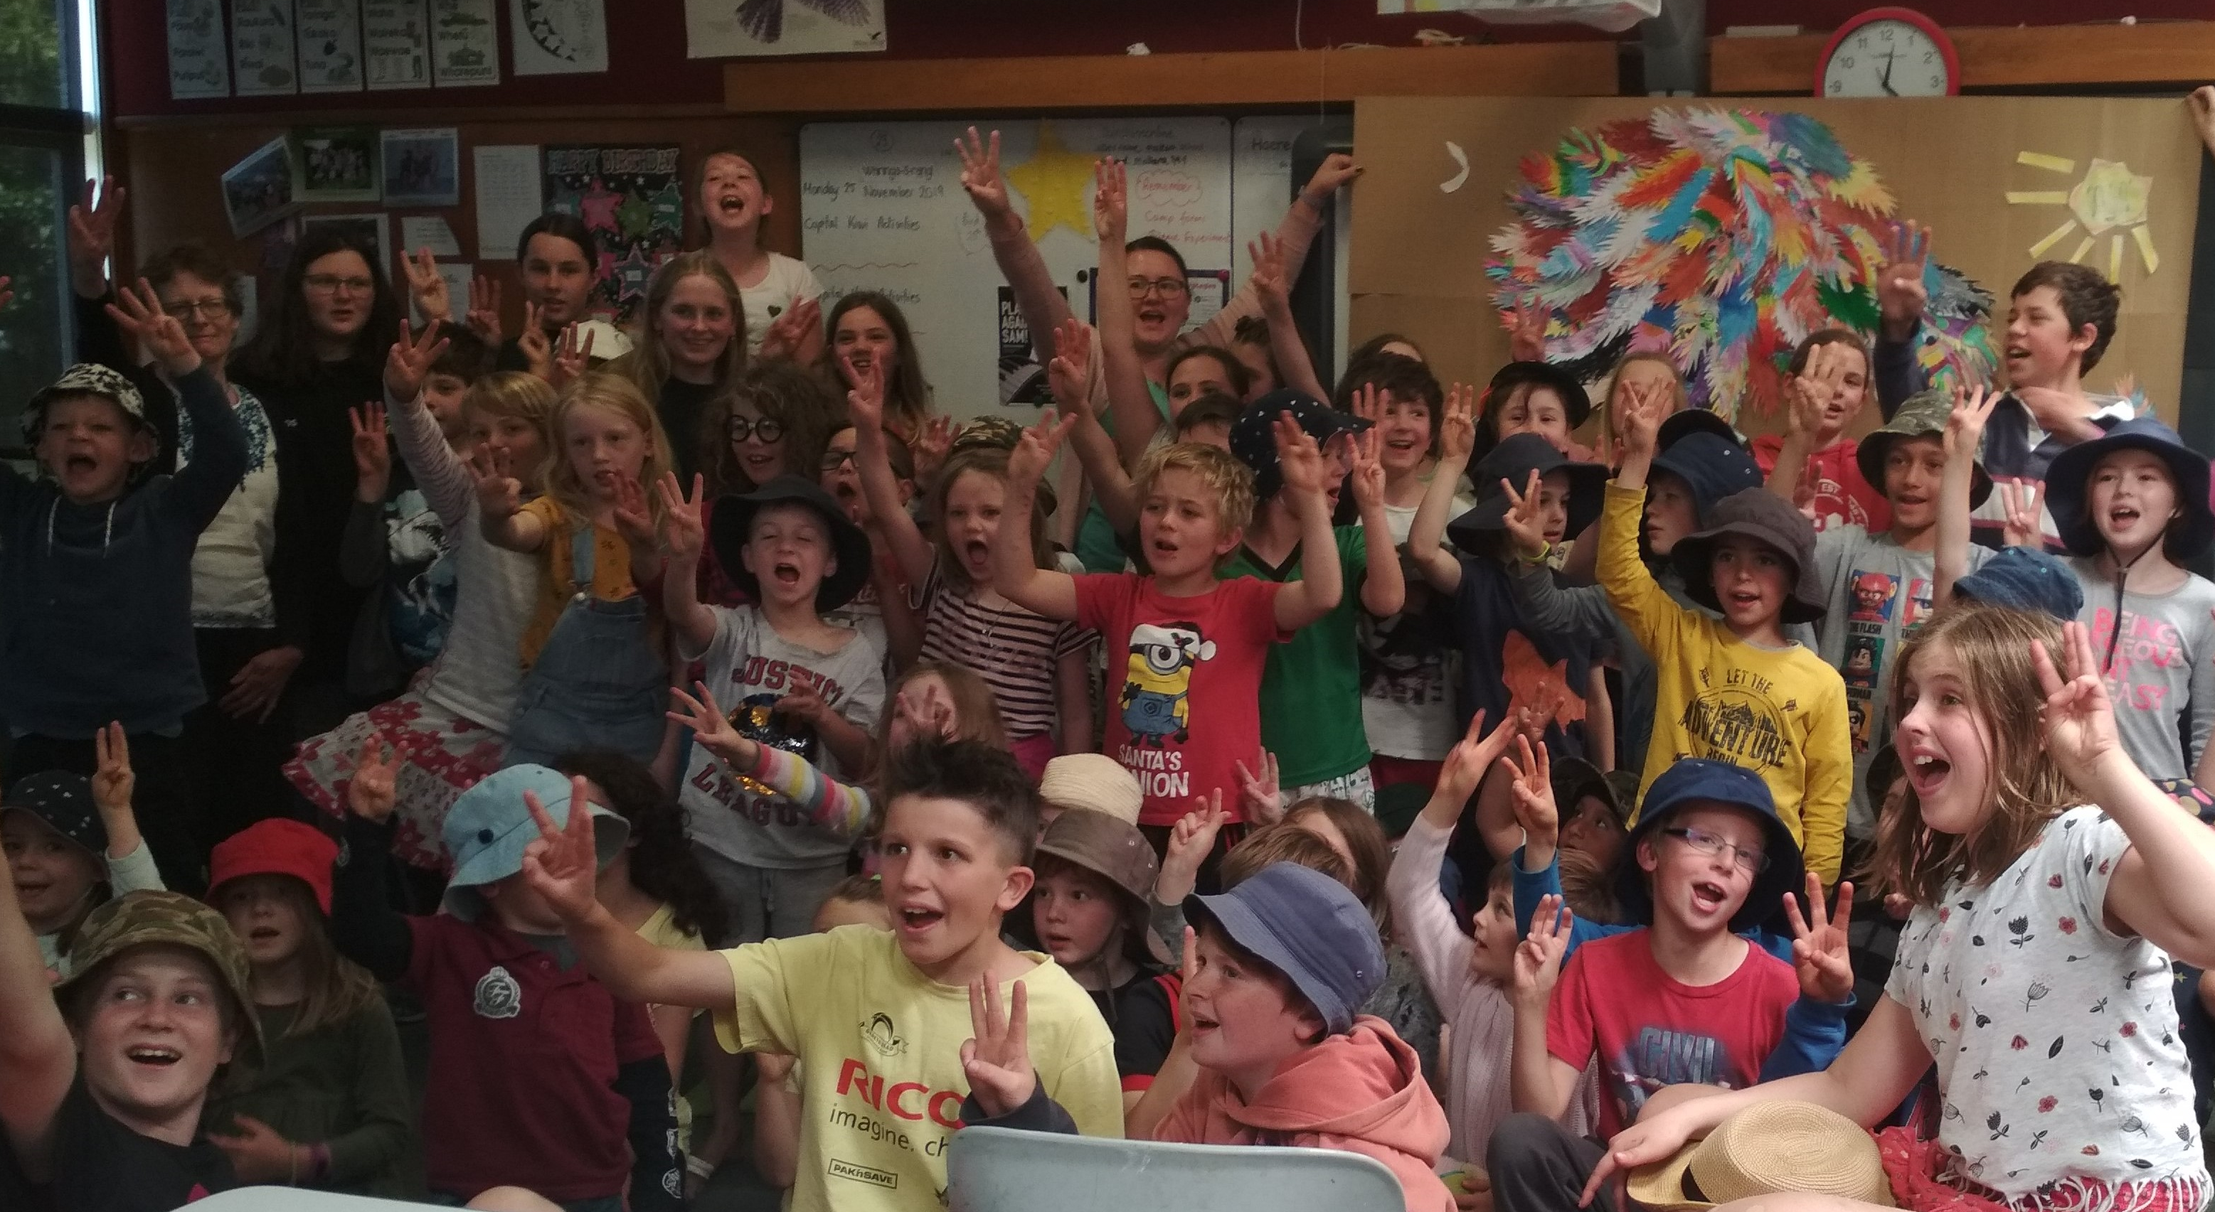

We believe children learn good citizenship and achieve happiness by belonging to a caring, connected community of learners.

Woven throughout our programme the following competencies and principles help our children learn, work and contribute to our community in positive ways.

Enviroschools kaupapa – five guiding principles

Empowered Students, Sustainable communities, Learning for sustainability, Maori Perspectives,
Respect for diversity of people and cultures

KEY COMPETENCIES
Capabilities for living and lifelong learning

THINKING, USING LANGUAGE, SYMBOLS & TEXTS, MANAGING SELF
RELATING TO OTHERS, PARTICIPATING & CONTRIBUTING

Strategic goals

- To provide best practice teaching and learning programmes that meet children’s individual needs and abilities, enabling them to become confident, connected, actively involved, life-long learners.

- To ensure our school welcomes and supports all learners, through total commitment to inclusive practices, including students with special learning needs

- To support our vision by ensuring continuous improvement of our self review and development processes.

- To support our vision by attracting and retaining quality staff who inspire and empower the students’ learning and lives.

- To support our vision by having a strong financial base and an inspiring physical environment from which to deliver education.

- To support our vision by providing a fun and safe physical, emotional and social school environment.

Student achievement Baseline Data
Students’ Learning | Student Achievement Results – Five Year Analysis  We have had an overall increase in achievement in maths since 2016. During 2016 our roll increased significantly and a high percentage of our new students were below in maths. We worked on implementing maths conversations to increase levels of student engagement and explored other strategies for improving engagement in maths through our maths PLD provided by Te Toi Tupu during 2017 and 2018. This led to a significant improvement in achievement by the end of 2017. We continued our PLD in 2018 working on improving student and teacher confidence in maths learning and teaching. We focussed on attitudes, discussing the merit of mistakes as learning opportunities and put teaching strategies into place to reduce anxiety around maths. Teachers were given support to “front load” targeted students before maths lessons and also supported to spend more uninterrupted time with groups containing target students. We found it best for our students to keep them in their normal learning environment and give them more time with the teacher rather than remove them to work separately. We used problem solving and authentic learning opportunities to engage students and investigated the use of collaborative learning groups with specific roles. Our Maths PLD continued in 2019 and with 2 new teachers joining the team we ensured the learning we had already undertaken would continue to impact positively on student engagement and achievement through consolidation and a continued focus on student success, authentic/rich learning tasks, collaboration and learning from mistakes. This work led to a significant increase – 12% - of students achieving at or above expected levels for the end of 2019. This achievement level has continued into 2020 and despite a disrupted year, our students have largely retained their achievement levels in maths. Most students from year 5 and all from year 6 and above are achieving at or above expected levels, A great result which indicates that the programmes in place are solid and sound and effective for our students’ learning. The focus on authentic learning and making learning meaningful, fun and collaborative has given our students more confidence in maths and improved their results. During 2021 staff will be sharing ideas in maths, recapping what makes an effective maths programme and observing maths programmes in other classes as part of our “in school” PLD. Maths will be a focus for teacher observations. TA support will be used for students requiring more one to one attention  In reading we are seeing a sustained level of excellent achievement. There was an increase in 2016 of children achieving below expected levels due to our roll growth. Over the last four years we have had excellent support from our RTLit and we have maintained and increased our teacher aide support with identified children. During 2018 we were involved in a pilot programme – Mahi Tahi – which involved two teachers working closely and regularly with the RTLit to improve outcomes for specific students that teachers identified as needing more support. This programme not only benefits the students taking part, but also upskills and supports the teachers. These skills can then be utilised with other students as required. The programme continued into 2019. The increase of support given to students and the upskilling of teachers combined have resulted in excellent outcomes for students with an improvement of 10% of students achieving at or above expected levels at the end of 2019. During 2020 we were fortunate to have both our RTLit and a reading recovery teacher working with our targeted tamariki. We have maintained an excellent result for reading achievement, with the same 94% at and above expected levels as in 2019. Looking at patterns – most year 3’s and all students from year 4 and above are achieving at or above. In 2021 we will continue to utilise the services of the RTLit and ensure that our progammes are meeting the needs of students through regular monitoring and review of resources and programmes. TA support will be used for students requiring more one to one attention – these will be our junior children.  Results for writing show an increase of students achieving at or above expected levels during 2020 and overall since 2016. During 2016 our roll increased significantly and due to a high percentage of our new students being below in writing our below percentages increased. With a focus on ensuring that children have daily opportunities to write, constructive feedback from teachers, along with self-reflection so children know what they need to work on to improve, throughout 2017 and 2018 we saw an improvement in results, reducing our below percentage from 22 to 9% However in 2019 we saw a 5% decrease of students achieving at or above expected levels. This has been a focus area for 2020, with particular attention to student motivation and a focus on next steps for individuals and groups. The teachers worked on ensuring that writing is meaningful and relevant to students and whenever possible there is an authentic reason for writing. We are pleased to see that we have increased our achievement in writing to 90% at or above in 2020, an increase of 4%. We will continue to ensure that students get regular and meaningful reasons for writing and effective feedback to ensure good progress is made. Most students from year 5 and all from year 6 and above are achieving at or above expected levels. TA support will be used for students requiring more one to one attention  Overall these percentages 94% reading, 90% writing and 92% maths are excellent. The trend or pattern we see when we look at the school overall is that as students move up through the year groups the “below” students feature less and less as those who have struggled when younger catch up and are at the same levels as their peers as they get into the higher year levels. This tells us that our interventions are working and although it can take time in some cases, students do catch up once the technical aspects of learning become clearer to them or the barriers to initial learning have been detected and dealt with.
  Year | Results – % of students below/well below @ End of Year | Total Student No.
  2016 | Reading 14% Writing 22% Maths 29% | 52
  2017 | Reading 11% Writing 13% Maths 11% | 63
  2018 | Reading 16% Writing 9% Maths 18% | 55
  2019 | Reading 6% Writing 14% Maths 6% | 50
  2020 | Reading 6% Writing 10% Maths 8% | 52
  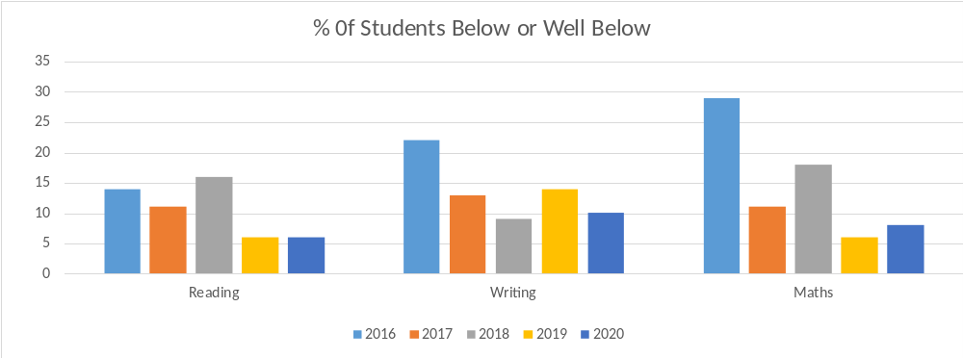
 | 2020 Reflections
Student Engagement | Our students are highly engaged in our programmes as we deliberately seek out topics for learning that fill a need for many students, are topical or are of interest to many students. We engage in hands on, activity based, authentic programmes of learning so that children are learning about and doing “real” things. For example, students are actively involved in the planning and running of our school Pet Day and they planned and are planting and maintaining their own native bush area in the school grounds. We have a school garden, orchard and extensive grounds with lots of opportunity for play to suit all ages and stages, a sandpit, goalposts, flying fox, extensive adventure play area, large bike track & bikes/helmets and a swimming pool which is very well used in the summer with daily lessons occurring. Our younger classes have continued to be engaged in “Play-based learning” during 2020 and the positive impacts to their learning and enjoyment of school have been exciting to see and have ensured that this will continue and grow.  We have ensured that writing, maths and reading are integrated into topics of interest to increase engagement levels and promote authentic reasons for applying literacy and numeracy skills. We actively seek out opportunities and activities that will be fun for students as well as involve thinking about others and appreciating differences – for example our involvement in the Pen pal initiative with the Illam in India, our involvement with The Litter Project (Sustainable Coastlines) and our engagement with Enviroschools and attaining our Bronze Award which led to leadership opportunities for our students and interesting activities to help the global community.  Our senior students are often involved in supporting the younger students – tuakana/teina and are encouraged to take an interest in them and be good role models. They take this seriously and staff consciously give them leadership and decision making opportunities whenever possible. We embraced The Makara Way and students have worked hard all year to show the attributes captured in the Makara Way. Students are rewarded by receiving a colour coded token when they are seen making good choices and once our school jar is filled up the whole school is rewarded! The tokens also provide an opportunity for statistical analysis. We believe that by giving attention to positive behaviour that we will see more of it. The students see the Makara Way as a positive, achievable way of conducting themselves and they all value it highly (this has come through in “student voice” very strongly).  2020 has not been without significant challenges. During term one the whole country was shut down (Lock down) for weeks while we tried to control the Coronavirus in our community. Our teachers and children had to suddenly convert to digital learning options and work from home. Students and teachers communicated through online learning platforms and we did all we could to get learning resources to families. We had a high rate of engagement from families in the online learning, but we are aware that for some of our families it was very challenging for a variety of reasons. When we did return to school, we remained on high alert and children/staff could not attend school if they were ill or showing any symptoms. Of course learning has been disrupted and the stress of the situation has had an effect. We have not seen a significant impact of this in our results for 2020, but it could be something that shows later as our younger students were not as well served by online learning as the older ones as the digital platform was far more challenging for them.  To add to our challenges the whole school had to move out for the last half of term 4 due to extensive renovations being carried out at the school. Again – the impact of this will not be seen in these results. We would hope any impact will be minimal, but the beginning of 2021 will also be affected as we will not return to our own school until term 2.
School Organisation and Structures | In 2020 we have maintained 4 classes/teachers. The board made the decision that the optimum size for MMS is four classes and we manage our enrolment scheme to that effect. Our junior class, Piwakawaka has NE – Year 1 students. Our second junior class, Tui has Year 1-2 students. Our middle class, Kiwi is Year 3-5 and our senior class, Karearea is Year 5 - 8. Teachers are encouraged to work together using co-teaching strategies when appropriate to ensure that optimum learning is taking place. The junior classes work together during Play-based learning sessions. Tuakana-Teina is widely used throughout the school week and it is fully ingrained in our school culture. Tuakana-Teina is used for academic work such as buddy reading and maths and also for sports/PE such as supported swimming and social science/science activities where students are whanau grouped to suit activities. Students are expected to help each other when they can and we encourage friendships and interactions between all ages and genders. During 2020 we continued PB4L (positive behaviour for learning started in 2019) which has had a positive impact on our practices around behaviour management as we have been able to focus and reflect on what we are doing and why we are doing it with trained facilitators to support us. The Makara Way was developed in 2019 to give us goals for our behaviour and values we adhere to, it has been highly successful with students and staff having ownership of it, it is living and thriving in the school and we continued to develop it in 2020. It is now fully embedded in our school culture and is highly effective and valued by all.  All students have homework and we use this as a way of helping parents understand what we are learning about at school. Reading is encouraged and expected at home for all students and junior students have a regime of reading and sight words with parents having high contact with the teacher to ensure things are going well at home. Oral language is well supported in the junior classes with families being given the weekly topic in advance so they can support their child in sharing ideas and information with the class. This focus continues through into the senior classes with collaboration encouraged and debating a popular and much enjoyed school event. A school wide focus on listening skills has seen an improvement in communication skills and general behaviour during group or whole school sessions. Contact between the school and families is high, we encourage parents to come into the school and have high levels of communication with them.  There is a school newsletter every fortnight and we have regular assemblies to celebrate student success and show the work students have been working on. Families are always welcome and we get good turnouts for these. We also have events such as pot luck dinners, school cross country, swimming displays, athletics events, sports days to celebrate events like the Olympics or Commonwealth Games, discos, concerts, productions, pet day and camps/overnight stays. Our community is always very supportive of these events as well as helping with the regular trips we take students on. Due to the pandemic some of our usual school activates have had to be changed or cancelled to adhere with nationwide restrictions. We have worked had to minimise the impact of this and have tried to keep calm and maintain as close to normal routines as possible. Our school community has coped well and has understood the measures we have taken to keep everyone safe.  We moved the original school building onto the school grounds towards the end of the year and will be working towards having it as a fully utilised school building during 2021. We spent the last 6 weeks of the term housed in two other local schools (renting rooms) as our whole school if undergoing renovation. We expect to be moving back into our “new” school in term 2 2021.
Review of Charter and Consultation | The charter is reviewed annually and periodically during the year with board members. Levels of consultation within the school community are high with surveys taking place regularly for students, staff and families. During 2020 we surveyed the school community on our health curriculum and our digital reporting trial. We piloted a trial into digital Snapshots (portfolios of student achievement and work) and surveyed the families involved leading to a decision to further rollout the use of digital Snapshots in 2021 to include the senior class. This will eventually roll out to the whole school. With impending changes afoot this year for school planning and reporting, we are planning community consultation around this during term 3 of 2021 to plan for 2022.

CURRICULUM
Strategic Goal 1:

To provide best practice teaching and learning programmes that meet children’s individual needs and abilities in preparing

them for the range of issues they will face in their lifetimes.

NAG 1

The Makara Model School Board of Trustees is required to foster student achievement by providing teaching and learning programmes which incorporate The National Curriculum, as expressed in The New Zealand Curriculum 2007 or Te Marautanga o Aotearoa.
Each board, through the principal and staff, is required to:
- develop and implement teaching and learning programmes:
  - to provide all students in years 1–10 with opportunities to progress and achieve for success in all areas of The National Curriculum;
  - giving priority to student progress and achievement in literacy and numeracy and/or te reo matatini and pāngarau, especially in years 1–8;
  - giving priority to regular quality physical activity that develops movement skills for all students, especially in years 1–6;
- through the analysis of good quality assessment information*, evaluate the progress and achievement of students, giving priority first to:
  - student progress and achievement in literacy and numeracy and/or te re matatini and pāngarau, especially in years 1–8; and then to:
  - breadth and depth of learning related to the needs, abilities and interests of students, the nature of the school’s curriculum, and the scope of The National Curriculum, as expressed in The New Zealand Curriculum 2007 or Te Marautanga o Aotearoa;
- through the analysis of good quality assessment information*, identify students and groups of students:
  - who are not progressing and/or achieving;
  - who are at risk of not progressing and/or achieving;
  - who have special needs (including gifted and talented students); and
  - aspects of the curriculum which require particular attention;
- develop and implement teaching and learning strategies to address the needs of students and aspects of the curriculum identified in (c) above;
- in consultation with the school’s Māori community, develop and make known to the school’s community policies, plans and targets for improving the progress and achievement of Māori students; and
- provide appropriate career education and guidance for all students in year 7 and above, with a particular emphasis on specific career guidance for those students who have been identified by the school as being at risk of leaving school unprepared for the transition to the workplace or further education/training.
* Good quality assessment information draws on a range of evidence to evaluate the progress and achievement of students and build a comprehensive picture of student learning across the curriculum.

2021 Strategic Objectives | 2022 Strategic Objectives | 2023 Strategic Objectives
- Professional development for staff in Maths, IT, Health, Inclusive Education, Behaviour, Te reo and tikanga Maori. | - Professional development for staff in  Assessment tools, IT, Behaviour  management and Science | 1. Professional development for staff in  Literacy, PE, PB4L & Sustainability
2. Curriculum focus – Maths, Te reo and tikanga Maori, Te ara o te Makara (KC) | 2. Curriculum focus/review– Science, IT & Sustainability | 2. Curriculum focus/review- Reading & Writing, PE/Health, Social Science
- Embed and further develop “The Makara Way –  Te ara o te Makara” | 3. To complete a positive review with the ERO team | 3.
4. Roll out digital reporting to senior class. Explore Aotearoa NZ’s Histories (new curriculum area) | 4. Review assessment procedures and implement any new strategies/procedures according to MOE guidelines | 4.
5. Fully embed play based learning | 5. Inquiry learning review | 5. Continue to modify play based learning strategies to suit our students.
6. Continue to teach te reo Maori and tikanga Maori throughout the programme, ensuring Maori perspective is included. | 6. Continue to teach te reo Maori and tikanga Maori throughout the programme, ensuring Maori perspective is included. | 6. Teach te reo Maori and tikanga Maori throughout the programme, ensuring Maori perspective is included.
2021 ANNUAL PLAN: CURRICULUM

2021 Objectives | Implementation | Responsible | Target  Date | Expected Outcomes | AOV
Professional  development  for staff in Maths,  IT, Health,  Inclusive  Education,  Behaviour,  Te reo and  tikanga Maori | - Review of maths PD – whole staff discussions and sharing  - Tips for Autism – staff to train and work with families  - Staff training – Kura Ahurea  - Incredible Years Training  - Navigating the Journey training for Yrs 1 to 4 teachers. | - Principal  - Teaching staff  - Support Staff  - RTLB’s IYP  - Kura Ahurea facilitator & TOA  - Family Planning | - IYP – terms 1 & 2  - Kura Ahurea throughout the year  - NTJ – Terms 2 & 3  - TFA – Terms 1 - 3 | - Staff have a cohesive behaviour management system to positively manage student behaviour in class and across the whole school, with particular focus on students with special needs.  - Staff will share knowledge and expertise around the Maths curriculum and use knowledge gained in class programmes.  - Confidence in teaching and learning Te reo and tikanga Maori increased and more evident in classroom programmes  - A whole school programme – Navigating the journey – introduced.  .
2. Curriculum focus – Maths, Te reo and tikanga Maori, Te ara o te Makara | 1. Review school statements for Maths & Te reo and tikanga Maori and Kc’s. | - Principal  - Teaching staff | - T1 – school statement exploration  - T2/3 modification/ reflection | - Staff will have a high level of understanding of the Maths, Te reo and tikanga Maori and Kc’s. statements and input in any modifications.
- Embed and  further develop  “The Makara Way  – Te ara o te  Makara” | - The Makara Way will be embedded in school documentation  - The Makara Way will be used to specifically teach students | - Principal  - Board  - Teaching staff  - Students | - Throughout the year | - School signage and documentation will reflect The Makara Way  - Awareness of the Makara Way will be high  - The Makara Way will be seen and heard and understood throughout the school  - School learning programmes will include aspects of the Makara Way – these will be evident.
- Roll out digital reporting to  senior class.  Explore NZ  History (new  curriculum area) | - Karearea class to begin using digital Snapshots  - Evelyn to upskill staff and report on progress | - Principal  - Teaching staff | - Throughout the year – review in relation to successes/ failures | - Students and staff in the senior class will confidently use a digital platform to share work and achievement with whanau.  - Whanau will have greater and more regular contact with student learning.
5. Fully embed play based learning | 1. Play based learning will be integrated into the weekly programme.  2. Strategies will be reviewed and modified regularly | - Principal  Teaching staff | Term 4 | Play based learning will be an accepted and beneficial part of the programme in the junior classes.  Teachers will modify the programmes to suit the learner’s needs  Junior teachers will work together to implement the programme and share learnings with other staff.
6. Teach te reo Maori and tikanga Maori throughout the programme, ensuring Maori perspective is included. | 1. Implement te reo in daily programmes  2. Planning includes Maori aspect  3. Kapa Haka by an outside provider | - Principal  - Teaching staff  - Kura Ahurea & TOA  - Te Rehia (Kapa Haka) | - Throughout the year  - T | - Te reo use will be evident in planning and programmes  - The “TOA” will lead the staff in the Kura Ahurea Programme and staff will participate and engage with the programme, implementing it into their daily programmes.  - Students will participate in Kapa Haka in terms 2 and 3

Supporting documentation includes

Achievement statements, curriculum overviews, curriculum folders and implementation plans, school wide achievement data, curriculum reports, pupil data files, assessment records, teachers’ planning

Inclusive Practices
Strategic Goal 2: To ensure our school welcomes and supports all learners, through total commitment
to inclusive practices, including students with special learning needs
An inclusive school is one which ensures all students, including those with special education needs, come to school (attend), enjoy school (engage), participate and achieve. Inclusive schools provide high-quality education tailored to suit the individual needs of students. They are safe and respectful learning environments.

The National Education Guidelines (NEGs) set a clear expectation that boards of trustees will identify students with special education needs and implement teaching and learning strategies to meet those needs (NEG 1, 2 and 7).

The National Administration Guidelines (NAGs) require all boards to identify students with special education needs and ensure teaching and learning strategies are developed and implemented to meet those needs (NAG 1).

2021  Strategic Objectives | 2022  Strategic Objectives | 2023  Strategic Objectives
1.Professional development for staff in meeting the needs of ORS students. | 1.Professional development for staff in inclusive practices PB4L | 1. Professional development for staff in  inclusive practices PB4L
2. Review support to “target” students in  Literacy and maths | 2. Review behaviour plans for whole school. | 2. Review Special needs policy/procedures
3. Property upgrades  will reflect inclusive philosophy | 3. Survey students to gain feedback on inclusive practices. | 3. Review special needs reporting and  contact with parents
4. Work with outside agencies when needed to meet students’ needs. | 4. Work with outside agencies when needed to meet students’ needs. | 4. Work with outside agencies when needed to meet students’ needs.

2021 ANNUAL PLAN: Inclusive Schools
2021 Objectives | Implementation | Responsible | Target  Date | Expected Outcomes | AOV
1. Professional development for staff in meeting the needs of ORS students. | Staff to work with facilitators from IYP (MOE) and TFA to develop practices and programmes to support students with special needs with their learning and behaviour.  Staff to participate in Tips for Autism Programme  Staff to work with MOE specialists to ensure learning and environmental needs are being met. | - Principal  - Teaching staff  - Support Staff  - IYP facilitators  - TFA facilitators  - RTLB and MOE specialists | Terms 1 -3 | - Increase students’ achievement, engagement and participation.  - Programmes used and developed to ensure students are included in everyday classroom activities.  - Systems in place to ensure inclusion of students is optimised  - Teachers confident to manage students  - The school environment and learning programmes will meet student’s needs.
- Review support to  “target” students in  Literacy and maths | Staff will work together to review and appraise support provided to target students. | - Principal  - Teaching staff  - Athena (RTLit) | - Terms 1-4 | - High levels of communication and understanding between staff to review and appraise learning support  - High quality systems are implemented  - Any changes or modifications to programmes implemented and monitored.
3. Property upgrades  will reflect inclusive philosophy | Decisions around property will be made with student needs considered. | Principal  MOE Property  Property Managers  Board | - Term 2 (end of) | - The school environment will be safe for all students.  - An upgrade in school buildings will be completed.
- Work with outside agencies to meet student needs. | RTLit, RTLB, MOE and SE will be involved when necessary | Principal  Teaching staff | Throughout the year | Individual student’s needs will be met. Students will make steady progress Use of specialist teachers where needed
Supporting documentation includes
Achievement statements, curriculum overviews, curriculum folders and implementation plans, school wide achievement data, curriculum reports, pupil
data files, assessment records, teachers’ planning, zoning material (advertising, process, communication

REVIEW
Strategic Goal 3: To adopt continuous improvement in our self review and development.
National Administration Guideline 2
Each board of trustees, with the principal and teaching staff, is required to:
- develop a strategic plan which documents how they are giving effect to the National Education Guidelines through their policies, plans and programmes, including those for curriculum, aromatawai and/or assessment, and staff professional development;
- maintain an on-going programme of self-review in relation to the above policies, plans and programmes, including evaluation of good quality assessment information* on student progress and achievement;
- on the basis of good quality assessment information* report to students and their parents on progress and achievement of individual students:
  - in plain language, in writing, and at least twice a year; and
  - across The National Curriculum, as expressed in The New Zealand Curriculum 2007 or Te Marautanga o Aotearoa, including in mathematics and literacy, and/or te reo matatini and pāngarau;
- on the basis of good quality assessment information*, report to the school’s community on the progress and achievement of students as a whole and of groups (identified through National Administration Guideline 1(c) above) including the progress and achievement of Māori students against the plans and targets referred to in National Administration Guideline 1(e) above.
* Good quality assessment information draws on a range of evidence to evaluate the progress and achievement of students and build a comprehensive picture of student learning across the curriculum.

2021  Strategic Objectives | 2022  Strategic Objectives | 2023  Strategic Objectives
1. Review policies and procedures as per the School Docs review cycle | 1. Review policies and procedures as per the School Docs review cycle | 1. Review policies and procedures as per the School Docs review cycle.
2. Curriculum review of Maths & Te reo and tikanga Maori and Kc’s. | - Curriculum review of Science, IT, Learning  Languages & Sustainability | 2. Curriculum review of Reading, Writing, Health/PE and social science
3. Link staff PD programmes to current needs of the students | - Link staff PD programmes to current needs  of the students | 3. Link staff PD programmes to current needs of the students
4. Refine student progress and achievement  reporting to BoT and community in relation to NZ curriculum | 4. Run BoT elections and induct new members | 4. Review health programme after community consultation

2021 ANNUAL PLAN : REVIEW
2021 Objectives | Implementation | Responsible | Target Date | Expected Outcomes | AOV
1. Review policies and procedures as per the School Docs review cycle | Follow School Docs review systems.  To use the site and make the school community aware of the relevant policies/procedures. | Principal  Board | Term 4 | By term 4 the review schedule for the year has been completed and any amendments have followed through into practice.  The school community will also have access to the site to view relevant policies and procedures.
- Curriculum  review of Maths &  Te reo and tikanga  Maori and Kc’s. | Each curriculum area will be fully reviewed in terms of our needs and the new curriculum Statements will include clear guidelines on delivery. | Principal  Teaching staff  Board | Maths – term 2  Te reo and  tikanga  Maori – term 3  KC’s – term 3 | By term 4 each procedure has been reviewed to make clear statements about curriculum delivery in these areas.
3. Link staff PD programmes to current needs of the students | During PD sessions staff will reflect on how their new learning can/will/does impact on student needs. | Principal  Teaching staff | Term 4 | By term 4 staff will have participated in PLD programmes that have assisted in their classroom practice.
4. Refine student progress and achievement  reporting to BoT and community in relation to NZ curriculum | Conduct community consultation (survey) on health programme | Principal  Teaching staff  Board | Term 3 | Board and staff will review outcomes of survey and review curriculum to ensure needs are being met.

Supporting documentation includes
Annual reports, board reports, schedules of review, review reports, performance agreements, assessment records, pupil data files, pupil reports

PERSONNEL
Strategic Goal 4:
To attract and retain quality staff who inspire and empower the students’ learning and lives.

NAG 3
According to the legislation on employment and personnel matters, the Makara Model School Board of Trustees is required in particular to:

(i) | develop and implement personnel and industrial policies, within policy and procedural frameworks set by the Government from time to time, which promote high levels of staff performance, use educational resources effectively and recognise the needs of students;
(ii) | be a good employer as defined in the State Sector Act 1988 and comply with the conditions contained in employment contracts applying to teaching and non-teaching staff.

2021  Strategic Objectives | 2022  Strategic Objectives | 2023  Strategic Objectives
1. Principal’s Performance Agreement in  place at beginning of Term 1. | 1. Principal’s Performance Agreement in  place at beginning of Term 1. | 1. Principal’s Performance Agreement in  place at beginning of Term 1.
2. Teaching staff Performance Agreements to be in place in term 1 | 2. Teaching staff Performance Agreements to be in place in term 1 | 2. Teaching staff Performance Agreements to be in place in term 1
3. Ensure all new staff are fully inducted | 3. Ensure all new staff are fully inducted | 3. Ensure all new staff are fully inducted
4. Ensure appraisal procedure is rigorous and linked to the professional development | 4. Ensure appraisal procedure is rigorous and linked to the professional development | 4. Ensure appraisal procedure is rigorous and linked to the professional development
5. Implement performance management  system, report to BOT. | 5. Implement performance management  system, report to BOT. | 5. Implement performance management  system, report to BOT.

2021 ANNUAL PLAN : PERSONNEL
2021 Objectives | Implementation | Responsibility | Target  Date | Expected Outcomes | AOV
1. Principal’s Performance Agreement in place at beginning of Term 1. | - The Principal and Board Chair complete the performance agreement | - Principal  - Board Chair | Term 1 | - Principal has a clear set of goals to work towards.
2. Teaching staff Performance  Agreements to be in place in Term 1 | Individual PD plans for staff are developed to cater for:  - Teaching and learning needs  - School focus  - Government initiative  - Peer monitoring | - Principal | - All year | - PD matches the teacher and school goals for the year.  - PD impacts on improving quality of teaching and learning practices.  - Government initiatives are addressed.
3. Ensure all new staff are fully inducted | - Induct any new staff | - Principal | - Term 1 or through-out the year. | - New staff are welcomed.  - New staff have appropriate job descriptions, performance contracts and agreements  - New staff are fully informed.
4. Ensure appraisal procedure is rigorous and linked to the professional development plans. | - Appraisal system used shows clear links to PD plans and staff members choose goals within the framework | - Principal | Term 1 | Clear links are made between the appraisal process and school development areas
5. Implement performance management system, report to BOT. | - Principal to carry out staff appraisals | - Principal  - Board | - Term 4 | - Appraisal system will help staff improve their practice.  - Principal will report to board on appraisal progress.

Supporting documentation includes Codes of conduct, collective and individual employment contracts, professional standards, job descriptions, performance agreements, EEO plan and reports, performance management and appraisal documentation, annual staff development plan, personnel files, staffing usage and expenditure reports, records of leave.

FINANCE & PROPERTY
Strategic Goal 5:
To have a strong financial base and an inspiring physical environment from which to deliver education

NAG 4
According to legislation on financial and property matters, the Makara Model School Board of Trustees is required in particular to:

(i) | allocate funds to reflect the school's priorities as stated in the charter;
(ii) | monitor and control school expenditure, and ensure that annual accounts are prepared and audited as required by the Public Finance Act 1989 and the Education Act 2016;
(iii) | comply with the negotiated conditions of any current asset management agreement, and implement a maintenance programme to ensure that the school's buildings and facilities provide a safe, healthy learning environment for students.

2021  Strategic Objectives | 2022  Strategic Objectives | 2023  Strategic Objectives
1. 5 year Property Plan: Implement | 1. 5 year Property Plan: Implement | 1. 5 year Property Plan: Implement
2.Special Projects:  Building Expansion – Space for roll growth  Whole School Renovation  Fencing and Playground reinstate and extension  Pool – paint and new cover | - Special Projects: | Special Projects:
3. Review property in relation to the needs of ORS students. | 3. Ensure good financial procedures are followed | 3. Review property in relation to the needs of ORS students.
4. Ensure the budget is followed and allows the school to meet obligations | 4. Ensure the budget is followed and allows the school to meet obligations | 4. Ensure the budget is followed and allows the school to meet obligations
5. Work with the auditor to ensure all financial practices are managed well. Update policies as needed. | 5. Work with the auditor to ensure all financial practices are managed well. Update policies as needed. | 5. Work with the auditor to ensure all financial practices are managed well. Update policies as needed.

2021 ANNUAL PLAN: FINANCE & PROPERTY
2021 Objectives | Implementation | Responsibility | Indicative  Budget | Target  Date | Expected Outcomes | AOV
- 5 year Property Plan:  Implement | - Complete general maintenance as specified in the 5YA | - Principal  - Board  - Ashby Property | $4,000 | Term 4 | - Maintenance needed will be completed
2.Special Projects:  Building Expansion – Space for roll growth  Whole School Renovation  Fencing and Playground reinstate and extension | Work with MOE to use available property funding to complete whole school renovations.  Upgrade original school building (onsite) to allow for use  Reinstate the adventure playground  Reinstate school fencing and extend new fencing around bike track. . | - Principal  - Board  - MOE Property  - Ashby Property  - Peryer Contractors | $1 300 000  $160 000 | Term 2  Term 2 | The school will be fully renovated and ready to use by term 2.  The original school building will be ready to use as part of the school by term 3.
3. Review property in relation to the needs of ORS students. | - Ensure grounds are safe and practical for students with special needs | - Principal  - Board  - MOE Property |  | Term 4
4. Ensure the budget is followed and allows the school to meet obligations  5.Work with the auditor to ensure all financial practices are managed well. | Budget control  Prepare financial audit for M.O.E. | Principal  B.O.T.  Office Manger |  | Review monthly  2021 budget in Term 4  By end of March  Through-out year | Monitoring of expenditure.  Review and reallocate funding where necessary.  Programmes are supported with adequate funds.  Avenues for income are fully explored.  5 copies financial statements to M.O.E. by 1 May  Audit outcomes will be adhered to.
Supporting documentation includes Annual reports, monthly reports, budgets, school buildings and systems inspection records/fitness certificates, property occupancy agreements, 10 year property maintenance plan, 10 year property development plan, job descriptions and schedules of work for caretaking/cleaning staff, asset register, depreciation and asset replacement plan

STUDENT AND EMPLOYEE SAFETY
Strategic Goal 6:
To provide a fun and safe physical, emotional and social school environment.

NAG 5
The Makara Model School Board of Trustees is required to:

(i) | provide a safe physical and emotional environment for students;
(ii) | promote healthy food and nutrition for all students;
(iii) | comply in full with any legislation currently in force or that may be developed to ensure the safety of students and employees.

2021  Strategic Objectives | 2022  Strategic Objectives | 2023  Strategic Objectives
1. Update Hazard Register. | 1. Update Hazard Register. | 1. Review and update Hazard Register.
2. Implement Plan to reduce hazards; to be  listed specifically. | 2. Implement Plan to reduce hazards; to be  listed specifically. | 2. Implement Plan to reduce hazards; to be  listed specifically.
3.Work with MOE, property managers and contractors to ensure student and staff safety is a priority during scheduled school renovations and upgrades | 3.Review and update policies and procedures as per review schedule | 3. Review and update policies and procedures as per review schedule
4. Review and update policies and procedures as per review schedule
5. Review outdoor shade and shelter provision in the school and improve where possible.

2021 ANNUAL PLAN: STUDENT AND EMPLOYEE SAFETY
2021 Objectives | Implementation | Responsibility | Indicative  Budget | Target  Date | Expected Outcomes | AOV
1. Review and update Hazard Register. | - Check buildings and outdoor areas regularly for any hazard  - Fire equipment is checked  - Heaters/fires checked | - Principal  - B.O.T. |  | - Updates and checks each Term. | - A ‘Hazard’ register which is regularly updated and is linked to the School Buildings System Manual and Buildings W.O.F.
2. Implement Plan to reduce hazards; to be listed specifically. | - Update Police “Vet” register. | - Principal |  | - Ongoing all year.  - Review Term 1. | All non-teaching permanent/fixed term  employees are Police vetted on a three year cycle.
 | - Update staff data base | Principal  School Secretary |  | End of Term 1 | - All staff on data base to include relevant information
 | - Practice and review emergency procedures | - Principal  - All Staff  - Students  - Principal |  | - Each Term. | - Emergency procedures are clearly defined and practised regularly.  - Emergency lists and contact ‘trees’ updated
3.Work with MOE, property managers and contractors to ensure student and staff safety is a priority during scheduled school renovations and upgrades. | Develop and agree to a safety plan for the duration of any work being carried out on the school grounds with input from those carrying out the work. | - Principal  - Ashby’s Property  - B.O.T  - Contractors |  | - Term 3 | - An effective safety plan will be in place and understood by all those on site during any building/improvement work being undertaken in the school grounds.
4. Review and update policies and procedures as per review schedule | Board will review and update policies/procedures on the School Docs site | - Principal  - B.O.T. |  | - Term 1 | - Board will be familiar with and adhere to policies relating to health and safety.  - Policies will be reviewed as per schedule
5. Review outdoor shade and shelter provision around the school and improve where possible. | Review school outdoor areas to identify any areas that can be improved by providing shade or shelter | - Principal  - B.O.T.  - Ashby’s Property |  | Term 4 | - The school will have further areas for outdoor learning that provide shelter and or shade.
Supporting documentation includes: Behaviour management files, incident and accident reports, immunization register, incident book, special needs register, at risk pupil files, attendance registers, building certificate of fitness, teacher records, emergency plan, police vet documentation

